Welcome to The Hendred’s Preschool
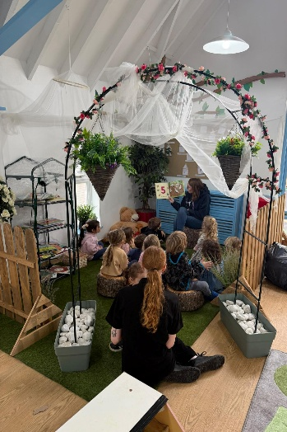
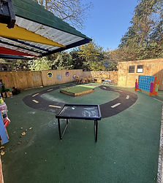
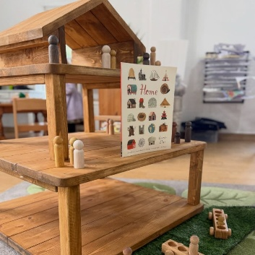

A Warm Welcome
We hope that you find this handbook contains useful information to support you and your child during your time at The Hendred’s Preschool. Within these pages you will find details about our daily routines, procedures, and the people who help make The Hendred’s Preschool such a warm, nurturing, and inspiring environment for local children and families.
The Hendred’s Preschool is a charity-run preschool based in the heart of East Hendred and has proudly served the local community for over 20 years. Set within a welcoming and stimulating environment, we provide children with opportunities to learn through play, exploration, creativity, and hands-on experiences both indoors and outdoors. We believe that children thrive when they are given the freedom to follow their interests, develop independence, and build confidence at their own pace.
Outdoor play is an important part of daily life at preschool, and children have regular access to our outdoor learning spaces throughout the year. We encourage curiosity, imagination, physical development, and a connection with the natural world through a wide range of activities and experiences.
Our experienced, qualified, and caring staff provide a varied and engaging programme for children aged 2½ to 4 years. Activities are carefully planned around children’s interests and stages of development, supporting their learning across all areas of the Early Years Foundation Stage. We are committed to ensuring every child feels safe, valued, and included, and we work closely with families and external professionals where appropriate to support children with additional needs.
As a registered charity, we greatly value the support and involvement of parents and the wider community. The preschool is overseen by a voluntary management committee, many of whom are parents or carers of children attending the setting. The committee plays an important role in supporting the preschool’s development, fundraising activities, finances, policies, staffing, and the continued growth of our provision for future generations.
We hope that your child enjoys a happy and memorable time at The Hendred’s Preschool and that your family feels very much part of our preschool community. Staff and committee members are always happy to answer questions, listen to ideas, and work together with families to provide the very best experience for every child.

Aims and objectives:
As a charity-based preschool, we are dedicated to providing high-quality early years education that fosters Respect, Independence, and Challenge—the core values that shape everything we do. Our Ethos At The Hendred’s Preschool is we believe that every child is unique, capable, and full of potential.
Our approach encourages:
✔️ Respect – Teaching kindness, inclusion, and positive relationships.
✔️ Independence – Helping children build confidence and essential life skills
.✔️ Challenge – Encouraging curiosity and a love for learning through play and exploration.

Opening hours
We are open Monday to Friday during term time. There is a handy copy of our term dates for the upcoming year, this is also on our website with any key dates.
The sessions we offer are:
AM session 9am-12pm
ALL DAY session 9am-3pm.
Parent’s can choose which days their child attends and whether it is for a morning session or all-day session subject to availability. We require a minimum of 2 sessions equivalent to 12 hours. We offer the full 15 hours and 30 hour funding entitlement from the term after your child turns 2.
On Arrival
Please arrive promptly for the start of session and wait in the hallway with your child for the staff to open the door and welcome your children in. Late arrival disrupts the flow of the session so if you are going to be unavoidably delayed by more than 5 minutes, please ring to let us know.
On arrival, please place your child’s lunchbox into the lunchbox trolley and their water bottle in the caddy.
We ask for you to say goodbye in the lobby and encourage to come into preschool independently and for children to put their own things on their pegs with our staff support. If there is any information that you need to share with us, such as a bump or incident at home or a change of person collection your child, please do so at this time. If you need a longer chat with your child’s keyperson or the manager, please allow time to wait until all the children have been taken in. Alternatively, you are welcome to telephone or email us at any time to ask to speak to your keyperson, the manager or to pass on a message.
The staff will then guide your children into the activities set up for the day/get ready for a morning group time to complete self-registration.
Settling in
We offer settling in sessions wherever possible for each child before they start as we find this helps with the initial familiarisation with key staff, including your keyperson and the preschool setting. Every child is unique and settles differently and occasionally you may need to stay with them to help build confidence in the new surroundings. This may take a few minutes or a few sessions: your child’s keyperson will advise you when the time is right to leave them. If we have a big intake in September, this may look differently and we may do a group settle and ask for flexibility during their first week.
We typically offer
First settle: Hour with parents.
Second settle: Hour without parents
Third settle: 2 hours without parents.
In most cases, a child takes the same time to settle on arrival regardless of whether their parent stays for 20 minutes or just drops them off with a staff member and leaves. We will always contact you if your child is taking a bit longer to settle to discuss options to help them and you are always welcome to call anytime and ask how they are.
The preschool session
We believe in a holistic approach which involves nurturing and caring for your child as well as meeting their educational needs. The routines and activities that make up the pre-schools session/day are provided in a way that:
- Helps children to feel valued as a member of the preschool.
- Ensure the safety of each child.
- Helps children to gain from the social experience of being part of a group
- Provide children with learning opportunities to help them to value learning.
The children can choose from, and are encouraged to take part in a range of mixed, adult led and child led activities. We encourage children to follow their interests and we support them.
Session timetable:
- Group time
- Interest/topic activities that the children and staff can adapt as they explore.
- Rolling snack time – children can choose to sit down for snack if they woud like.
- Lunch time
- Adult led and child led activities (indoors and outdoors) in small focus groups throughout the session.
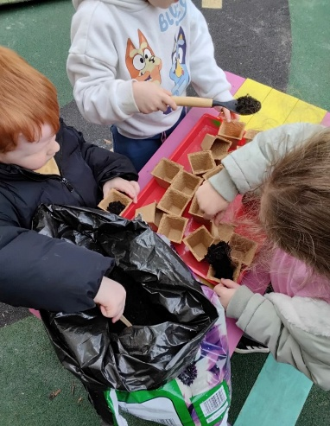

- Group time

Collecting your child
The staff will open the door at the end of the session and will bring your child to you in the hall. Please arrive promptly. If you are going to be delayed by more than 5 minutes, please ring to let us know. A late fee will be charged for persistent lateness. If you need to collect a few minutes early to collect to get to another school to collect a sibling, please do let us know in advance.
You must keep us informed of the persons who is collecting your child and provide a password. Please give us as much notice as possible by emailing or calling the setting with their name and contact details. If it the first time they are collecting, they will also need to bring some ID for us to check. If we are not sure on the person coming to collect, we will contact you before we release your child.
Car Park
We are very lucky to have a large car park however as majority of our families live in the village, we do encourage you to get into the habit of walking. The car park does get quite busy during drop off and collection times due to a lot of parents parking here to walk to collect their children from the schools in the village, so please take extra care during these times.

What to wear
Please ensure all belongings are labelled with your childs name, especially coats, hats, footwear and jumpers. We urge you to dress your child in clothes that are easily washable and that you won’t mind getting messy. We encourage children to use skills that will help them to become independent, like putting on their own coats and taking themselves to the toilet. Simple clothing that they can manage themselves will help them to do this.
Shoes – that they can put on themselves or with little support should be suitable for activities on offer and should stay firmly on their feet.
YES
- Velcro fastening shoes are best so that children can learn independence by removing and putting on their own shoes.
- Wellies, please provide a named pair of welly boots to be kept at The Hendred’s Preschool as we go out in all weather conditions.
NO
- No shoes with laces please.
- No open toe sandals or flip flops.
If your child wears wellies to preschool during wet weather, please ensure you bring a pair of dry shoes for them to change into on arrival.
Small bag
Please provide a bag with spare clothes in daily. We ask that this isn’t a drawstring bag for safety purposes. You are more than welcome to leave their bag on their peg, however we do ask that you check regularly to see if there are any clothes that need washing/replenishing. For safety reasons, please do not put anything else in the bag.
Jewellery – with the exception of stud earrings, is not permitted for safety reasons, cultural and religious requirements will be respected but please discuss these with the manager.
Nappies – if your child is still wearing nappies or equivalent, please provide your own nappies and wipes. Your child’s keyperson will work with you towards toilet training at an appropriate time.
Suncream – As a setting we provide suncream for all children, we supply Nivea Kids Protect and Sensitive, 50+. If you are happy for your child to use this suncream, you will sign a consent form. If your child is sensitive and you would like to supply your own, we ask for an unopened bottle, labelled with your child’s name to be kept here.
We ask that on a day where UV is to be high, that you apply suncream to your child before their session. We will apply/reapply each morning and afternoon.
Water bottle
Please bring in a named water bottle, containing only water. This should be an age appropriate bottle, eg: flip up spout that your child can drink from without adult help. We will refill this as necessary throughout the day. Squash or juice should not be added as this is not kind for the teeth and due to allergies. Medication such as Movicol should not be added under any circumstances.
Snack time
We provide a healthy and balanced snack each morning. We do take healthy snack donations; we just ask that the ingredients are displayed, packaging is unopened and in date. Fruit and vegetables should be bought in whole for hygiene reasons and will be washed before consumption. You are also welcome to give a financial donation if you would like.
Our snack time is a social time where children and adults eat and talk together. The children can choose when they would like to have snack as we do this on a rolling basis, so we do not interrupt play. Please note your child may not be offered the snack option they bought in that day, if we have other options that need using first.
We encourage independence during snack times as much as possible e.g.: pouring their own drinks, spreading the butter on a cracker etc.
Packed lunch
We discourage packed lunches that consist largely of crisps, sweet drinks, biscuits and chocolate. To avoid the risk of choking, please cut any grapes, small tomatoes, olives etc in half lengthways. Please do not include popcorn, sweets, nuts, Nutella, or peanut butter in your child’s lunch.
For the younger children, the contents of each lunchbox may be put onto plates and placed on the lunch table with their name card. Staff sit with the children and will encourage them to eat their savoury food before the sweet food and may feedback suggestions to you as appropriate.
To help with the transition to school, the older children are given their lunchbox to open themselves, staff will assist with opening packets. Please note that any uneaten or part-eaten food remains will be returned home as that is what will happen during school.
Dogs
Dogs are not allowed on the premises unless a guide dog for health and safety reasons. We do love furry friends but please do not bring your pet with you on the walk to preschool, as they are not allowed in the building and they will be left unsupervised if left outside.

Allergies
The Hendred’s Preschool is a NUT FREE zone. Please do not bring snacks or lunches that may contain nuts. If your child suffers from any allergies, please discuss this with your keyperson. A list of children with allergies is kept in the kitchen for quick reference when the snacks are prepared. We ask that snacks are provided in their original packaging so that the ingredients and allergy information can be checked before use.
Contact and health details
Please inform us immediately of any changes to:
- Your contact and emergency contact details (including address, phone and email).
- The person collecting your child.
- Your child’s health condition, medication requirements, allergies and food intolerances.
Holiday/Days out.
If your child will be going on holiday or having a day out of preschool other than for illness, please let us know by emailing, giving as much notice as possible. Unfortunately, fees cannot be waived, and sessions cannot be swapped for holiday absence.
Absence
Please give us as much notice as possible if your child is unable to attend their normal session for any reason as this must be recorded in the daily register. If we haven’t heard from you by the start of the session, we will call you within the hour to establish the reason for absence. If we still haven’t heard from you or been able to contact you, we will try and call your emergency contacts. In circumstances where we have been unable to make contact, we will follow our Absence Policy
Illness
If your child is not well, the best place for them to be is at home. Please call us by 9:15 am if your child will not be attending. If your child has diarrhoea and/or vomiting, whatever the suspected cause, you must keep them at home for 48hrs after the symptoms have stopped. This is a government recommended exclusion period. We reserve the right to refuse to admit your child if on arrival they have a high temperature, sickness and diarrhoea or symptoms of a contagious infection. If your child becomes unwell whilst in our care, we will call you and ask you to arrange for your child to be collected as soon as possible.
We do not allow children who have been given Calpol before a session to attend in line with our well child policy.
In order that we can keep other parents informed of the presence of infectious diseases at The Hendred’s Preschool please notify us if your child has any of the following:
Chicken Pox, Conjunctivitis, Measles, Rubella, Scarlet Fever, Whooping Cough, Threadworms, Ringworms, Hand Foot and Mouth Disease, Head lice, Swine Flu, Norovirus, Coronavirus.
Medication
Staff can administer prescribed medicine or cream to your child whilst at Pre-school; please speak to any member of staff on arrival who will ask you to complete a Medication form. The medicine bottle or container must contain the pharmacy label. It is your responsibility to collect and take home the medication at the end of the day. Unfortunately, we cannot give over the counter medicines like Calpol unless it is an emergency -high temperature, febrile convulsions and we have first contacted you to advise of the circumstances.
Please do not leave creams, medicines and cough sweets in your child’s bag for safety reasons or put Movicol, or similar, in your child’s water bottle.
If your child has a long-term on-going medical condition, for example asthma, we will ask you to complete a Healthcare Agreement form. On-going medication, including asthma inhalers, must be kept at Hendred’s Preschool during term time, any medication not claimed and taken home at the end of term will be discarded. You should ask your doctor to prescribe a second set for use at pre-school, we cannot allow children onsite without their inhaler, EpiPen or other lifesaving medication, if they have been prescribed one. Any changes in medical conditions must be notified in writing, and a new Healthcare Agreement form will need to be completed.
Safeguarding Children
Safeguarding children and young people is everyone’s business.
Our designated safeguarding lead (DSL) is: Natasha Thorngate (Manager)
Assisted by: Cherrelle Taylor (Deputy Manager)
Pip Gibson (SENDCO).
If you have a concern about a child at the Hendreds Preschool, please speak to any of the above staff. There are further contact details for support and advice in the safeguarding children policy. We do display these on noticeboards also.
All of our staff are DBS checked and have received safeguarding training. We have procedures in place to ensure the protection of children from those in setting who have not been checked with the DBS.
All parents must be aware of and agree to follow our Safeguarding Children Policy and procedures and sign a declaration that they will do so. A copy of the full policy is on our website
Mobile Phones and Cameras.
Staff, parents and visitors attending The Hendreds Preschool are asked to leave their mobile phone or camera, smart glasses or smart watch in the office while on the premises in accordance with our Safeguarding Children policy.
The Key Person system
Every child has a key person who will help ensure that your child’s learning and care is tailored to meet their individual needs. The key person is responsible for liaising with you, observing your child, planning and recording your child’s ‘learning journey’.
During the visits before your child starts, your key person will start to build up a relationship with and a profile of your child. These visits will also provide you with the opportunity to discuss your child’s individual needs, abilities and interests. Our staff work in keyperson buddy groups so if your allocated keyperson is not available during any session, your child has another familiar adult to support them.
Changes in the home environment can often result in a change in a child’s behaviour at Hendred’s that may not be evident at home. Please notify your key person of any changes that may affect your child, such as death of a pet or family member, change in family circumstances, or if you are moving home. You should also keep your key person informed of any changes in health conditions, appointments or other professionals involved in your child’s care.
Keeping you and us informed
We use email as the primary way to communicate a variety of information including newsletters, details of events and parents’ evenings, pre-school and fund-raising activities and reminders of forms due.
We use Tapestry to record your child’s progress, and you can view this online. We encourage you to add your own notes of your child’s interests and achievements at home for your key person to see. This helps build a picture of their progress that we might not see at Hendred’s and plan their next steps and activities.
Our website contains a lot of information about the pre-school including term dates, fees, dates of meetings and events, policies and procedures, a copy of the handbook; and links to other useful websites.
Noticeboards in the lobby and outside display statutory information such as Ofsted registration, insurance details, and committee meeting minutes, as well as information mentioned elsewhere in the handbook like term dates, behaviour rules, parent help ideas and staff pictures.
We can also signpost you to information about other local children’s groups and activities and local sources of advice and support.
If you have any questions at all, please do ask any of the staff or call us and we will do our best to help or put you in touch with the best person to help whether it is a member of staff, committee or external agency.
Changing Sessions
If you would like to change or increase the sessions your child attends at any time, either a one-off additional session or permanent change, please give as much notice as you can. Ask any member of staff or email. If the session requested is currently full, we will place your child on the waiting list and inform you as soon as a place becomes available.
Notice of leaving
One month’s notice of leaving is required but it would help considerably if we could have as much notice as possible. If you don’t give the required notice, you will be liable for any fees due for the notice period.
Parent/Staff Meetings.
Two or three times per year we hold parent’s evenings when you can speak to your child’s key person about your child’s progress. The first meetings early in the academic year are usually informal ‘Meet the staff and committee’ events and are an opportunity to look round the room at what we do and to meet and chat to other parents, staff and committee members. Towards the end of the year, there is a more formal meeting with your child’s keyperson which, for children leaving to go to Primary school, focusses on school readiness.
We are always available for brief discussions about your child’s progress or welfare when you drop off or collect your child. We are also happy to arrange longer appointments, face to face or phone call, if required; please ask your child’s keyperson or the Manager if you would like to book an appointment.
Transition to primary schools
Many of our children move onto The Hendreds Cofe Primary School or St Amands in the village. We often are invited for visits to the school to watch their sports days/nativities and to use their facilities such as their libraries. Parents should be aware that their attendance at The Hendreds Preschool does not guarantee them a place at one of these schools. The allocation process is entirely in the hands of Oxfordshire County Council. For all children moving onto these schools, we are usually able to arrange an extra transition session.
We also work with other schools during the last term of the year to communicate and hand over to ensure the transition is as smooth as possible.
Privacy and Data Protection
Any personal information you supply to us will be collected, stored and used in accordance with the principles of the General Data Protection Regulations (GDPR) (2018) and our Records policy. A copy of our Privacy Notice explaining how we use your personal data is included at Appendix E. You will also receive a Privacy Notice in relation to information provided to the Oxfordshire County Council for funding purposes.
Funding
3 and 4-year olds are entitled to the universal 15 hours per week (5 half day sessions) of funding by the Early Education Fund starting from the January, April, or September term after their third birthday. At the beginning of each of these terms, we will ask you to complete a Parent Declaration Form to enable us to claim the funding for your child. We don’t offer the extended 15 hours funding (30 hours) but we are happy for you to share the funding with another setting.
Early Education Funding is also available for some 2.5 year olds. You will have received a letter and reference number from the County Council if you are eligible and you must let us know your child’s TYF reference number before your child starts. https://www.oxfordshire.gov.uk/residents/children-education-and-families/early-years education/free-education-2-year-olds.
We also accept the 15 and 30hrs working families funding for 2.5yr olds. In order to claim this you will need to have applied for a code via HMRC and must maintain a valid code for the time your child is eligible. If your child is new to The Hendreds preschool, they must have their code validated before the end of the preceding term and not be in a funding ‘Grace Period’ when they start with us. Again we are happy to share this funding with another setting.
Early Years Pupil Premium is paid for 3 and 4-year olds who meet certain eligibility criteria to support their learning. If you think you might be eligible, please check https://www.oxfordshire.gov.uk/cms/content/early-years-pupil-premium-information-parents, and fill in your details on the Parent Declaration Form so that we can claim it for your child.
Payment of fees for unfunded sessions
The current schedule of fees is included at Appendix G. Current fees are also displayed on noticeboards and on our website. If you would like your child to attend before they are eligible for funding, or for more than 5 pre-school sessions, you will receive an invoice for the fees due.
Fees are due at the end of every long term. All booked sessions must be paid for even if your child doesn’t attend due to holiday or illness. If the preschool has to close for more than 3 school days, we will refund fees paid for the remainder of the closure period.
We prefer payment by tax free childcare or bank transfer but may also accept cash or cheque. Cash or cheque payments should be put into a named envelope and handed to the manager or chair.
We accept payments via Tax free childcare, please let us know your unique reference number when making payments.
If you think you will be late making a payment at any time or need help with fees, please speak to the Manager or the Office Manager at the earliest opportunity to discuss payment options. Discussions will be in complete confidence.

What is the Early Years Foundation Stage (EYFS) curriculum and what does this mean for my child and me?
The EYFS is the government’s framework outlining standards for learning, development and welfare for 0-5yr olds. It contains both statutory requirements and good practice guidance. The framework is focused around seven areas of learning and development. It outlines the skills, knowledge and understanding your child will need to be able to successfully access the school curriculum at five and to work alongside others as he/she gets older.
The seven areas of the curriculum are sub-divided into two areas, PRIME and SPECIFIC. Whilst all the areas are equally important, it is very difficult for a child to be able to access the rest of the curriculum without a good strong grounding in the PRIME areas of learning- everything builds on these skills and this is particularly important when children start school. Some guidance for ‘what is school readiness’ is included at appendix E.
At Hendred’s Preschool, we take great care to ensure that children have the best possible opportunities to hone their skills in these areas. These areas are assessed formally at age two and termly during their time here and at the end of the foundation stage in primary school against the Early Learning Goals. We will provide a final formal assessment of your child’s learning during their time here, a copy of which will also go to your child’s new setting or primary school.
PRIME AREAS OF THE EYFS
Communication and language | - Listening, attention and understanding.  - Speaking
Personal, social and emotional development | - Self-regulation  - Managing self  - Building relationships
Physical development | - Gross motor skills  - Fine motor skills

SPECIFIC AREAS OF THE EYFS
Literacy | - Comprehension  - Word reading  - Writing
Mathematics | - Number  - Numerical patterns
Understanding the world | - Past and present  - People, culture and communities.  - The natural world
Expressive arts and design | - Creating with materials  - Being imaginative and expressive.

How will The Hendred’s Preschool support my child to reach their full potential?
Your child’s key person, in collaboration with you, will observe your child noting particular learning styles and needs and feed these observations into our weekly planning system. Any observations, photographs or notes will then form part of your child’s online Learning Journey on the Tapestry online system. Tapestry is available for you to access and add your own comments to your child’s Learning Journey and at any time via a secure login. The whole Learning Journey provides evidence for our formal assessments and next steps.
How can I help my child?
Good learning experiences are inextricably bound up in purposeful every day events and reading and talking to your child are probably the most valuable things you can do. Other suggestions are
- Pointing out signs and labels in the environment.
- Cooking together – reading recipes, measuring, counting, turn taking.
- Writing for a purpose, shopping lists, signs and notes.
- Following your child’s interests. “Lets see what we can find out about dinosaurs?”
There is more information for parents at www.foundationyears.org.uk/eyfs-statutory framework and the Parents Guide to the EYFS is a very useful guide.
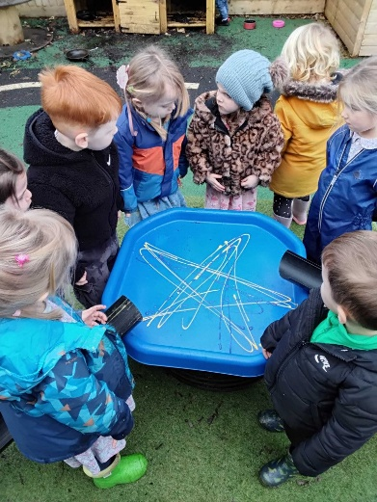
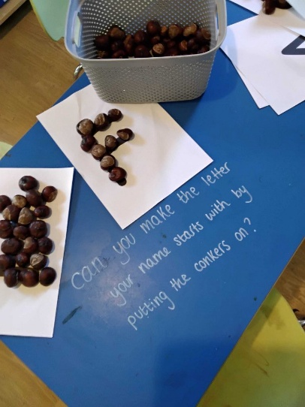
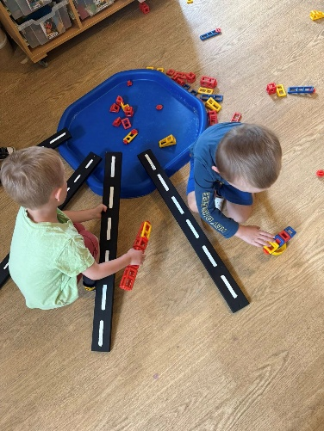

Record keeping – the ‘Learning Journey’ and Tapestry.
We keep a record of achievement - a ‘learning journey’ - for each child making reference to the EYFS curriculum. On-going assessment involves observing each child and planning their learning to reflect their level of achievement and interests. This is recorded in your child’s learning journey and used by your key person to plan their next steps.
We use an online journal system called Tapestry. The staff use iPads to upload observations and photos to the child’s record. (The iPods are stored securely; no information is stored permanently on the iPad itself and they are not taken off the premises). You will be given a login to view your own child’s profile and you can also add your own comments and share observations of your child’s achievements at home with your key person.
When you first access the Tapestry system, please complete the ‘All About Me’ page.
Football sessions
We have Serious 4 Sports come in on a Friday morning to do a half hour football session with the children. These sessions are linked to the EYFS as well as supporting the children with being active and using teamwork which fits perfectly with our values.
Special Educational needs and disabilities
As part of the pre-school’s policy to make sure that our provision meets the needs of each individual child and their family, we take account of any special needs a child may have.
If we feel your child may benefit from some extra support/input such as small group work to build confidence or improve language skills, or more specialist support from other agencies, your key person and Natasha, our Manager and Pip our SENDCo, will discuss this with you and we may be able to claim additional funding to help us support your child. If you have any concerns about your child’s development or needs, please speak to your child’s key person in the first instance and ask for advice from the Manager.
Behaviour Management
We encourage all children to consider and respect those around them and we offer very clear guidelines as to what is acceptable and what is not. We have a ‘Behaviour Rules’ poster (see Appendix D) on display around the Pre-school for all parents, staff and visitors to see and the rules are regularly discussed with the children.
Certain types of behaviour are always unacceptable, and we take time to carefully explain why this is so to the individual concerned and to maintain a consistent approach to dealing with such behaviour. We comfort any child who has been upset by another child’s inappropriate behaviour and work towards reconciliation by encouraging children to be independent and self disciplined and to negotiate their way through disagreements.
Saying ‘sorry’ is often very hard for a young child who may either say it without understanding the meaning or refuse to say it at all. We therefore work towards a restorative justice approach in which the child is encouraged to consider how the recipient of his/her unkind behaviour feels and what they could do to make amends or help them feel better..
We are committed to treating parents, carers and their children with the utmost respect. The staff team, committee members and other parents are entitled to be treated with the same courtesy and respect by all parents and carers of children attending The Hendred’s Preschool at all times.
Parent involvement and participation
The Hendreds Preschool recognises parents as the first and most important educators of their children. The staff endeavour to make Hendreds a stimulating place for the children to learn and thrive. They see themselves as co-workers with you in providing care and education for your child and in return will expect your support by:
- Making yourself available as and when required to discuss the progress of your child or any factor relating to their childcare place
- Exchanging knowledge about your child’s needs, interests and progress with staff.
- Sharing with us and the children any special interests or talents that you have.
- Take part in events, discussions and questionnaires about the activities and the curriculum of the pre-school
- Building friendships with other parents in the pre-school.
- Making suggestions for improvements to the setting and our procedures.
Parent Help
We encourage parent involvement by asking parents to help in the pre-school sessions. As well as enabling staff to spend more time with the children, it also enables you to see what the day-to-day life of the pre-school is like and help the children to get the best out of the activities. Requests for help will be circulated at the beginning of each term and will often coincide with a particular activity or event which staff would appreciate an extra pair of hands for. As well as helping with specific activities, if you have a special skill, talent or interest that could be shared with the children, for example, a musical instrument to show them at circle time, please do let us know. The staff really do appreciate your help and your involvement.

Donation
We do appreciate that not all parents have time to help during the sessions. There are many other ways that families can support Pippins, for example through assisting with fundraising or occasional maintenance or gardening tasks or attending committee meetings, but if you are unable to contribute any of your time to help and support us, we suggest making a donation each term.
The Hendred’s Preschool – The charity
The Hendred’s Preschool is a registered charity and all parents are invited to become a committee member. Please email Amanda Cotter, our chairlady at Chairofhendredspreschool@outlook.com for more information.
Management and Administration
While employed staff provide the care and education of your child and day to day operation of the pre-school, our volunteer Management Committee, manage the administration, maintenance and fundraising aspects of the setting.
The committee is responsible for:
- Making sure the pre-school works to policies which help it provide a high-quality service.
- Making sure the pre-school works in partnership with the children’s parents
- Employing and managing staff
- Managing the pre-school’s finances and arranging fund-raising events
- Maintenance of the premises and grounds.
- Development of the pre-school for the future
The major decision-making is in the hands of parents. Parents with children currently at Little Pippins must form the majority of the committee membership otherwise we cannot legally operate.
Parents are warmly invited to join the committee and to participate as much or as little as they would like to help ensure the pre-school provides the best environment for the children. You do not have to take on a particular role, there are many small tasks that help make such a difference to the running of Hendred’s Preschool. For the committee to be able to make decisions, there must be parents present at the committee meetings. The committee usually meets once per term, 5 or 6 times per year.
Fundraising and grants
Fundraising is essential to enable The Hendreds Preschool to open and remain financially viable. The majority of income from fees and government funding just covers staff costs. Therefore, we rely a great deal on fundraising and grant income to buy and replace equipment and toys, and maintain and enhance the premises for the future. If you have a suggestion for fundraising or would like to would like to help the fundraising team by seeking out grant opportunities, organising fundraising events such as a raffle, tombola stall, Santa’s grotto, suggesting ideas for events or just helping out on the day then please speak to any committee member or member of staff or respond to appeals for help.
Annual fundraising events that have been successful for us in the past have been:
- Halloween discos
- Beer festivals
- Dog show
- Summer fete
Health and safety
During the settling in visits, we will explain how we ensure the continued safety of the staff and children in our care including fire safety, door security, first aid and first aiders, visitors, no smoking policy. All our, risk assessments and safety checklists are kept in the offices, and you are welcome to ask questions or look at these at any time. Most importantly, please do not leave the premises without ensuring that a member of staff is aware that you are going and will lock the main door after you leave.
Policies
We will provide you with details of our policies and procedures at the settling in meeting. These outline how we satisfy the requirements of the EYFS in our everyday practice including admissions, behaviour management, nappy changing, hygiene, records and health and safety. Paper copies are kept in the lobby and they also on our website.
As previously mentioned, we specifically require parents to read our Safeguarding Children policy and sign a declaration to abide by it. The full policy is on our website.
Our policies are reviewed by the management committee annually and parents are required to abide by them. If you have any questions about our policies or procedures, why we do things the way we do, please do ask a member of staff.
Confidentiality
It is important to recognise that during any time you spend at The Hendred’s Preschool, confidentiality is adhered to. If you witness or hear any information that is confidential while you are on the premises, we request that you keep it so.
Information sharing
You may request access to any confidential records we hold on your child and family. We will always seek your consent where we need to share information about your child with any other professional or agency for example with external agencies or schools regarding any special needs your child may have or transition to school. Please be aware that we are obliged to share confidential information without authorisation from the person who provided it or to whom it relates, if it is to prevent a crime from being committed, or a matter of safeguarding a child or vulnerable adult.
Equality and diversity
We aim to ensure that our services promote equality of opportunity and valuing diversity for all children and families using the pre-school and to challenge and eliminate discriminatory actions on the basis of a protected characteristic: age, gender, gender reassignment, marital status, pregnancy and maternity, race, disability, sexual orientation, and religion or belief. The full ‘Inclusion - Equality and Diversity’ policy is available on our website and in the Policies folder in the hallway.
Code of conduct
Our staff are committed to treating parents, carers and their children with the utmost respect. The staff team, committee members, parents, children and visitors are entitled to be treated with the same courtesy and respect at all times by parents and carers of children attending Hendred’s Preschool.
Complaints
We have a complaints procedure which you should have been given a copy of when registering your child and is also included and is on our website. If you have an issue about any aspect of the Pre-school’s provision you should firstly talk over your concerns with your key person or the Manager at the earliest opportunity.
If a satisfactory outcome is not achieved within a couple of weeks you should formally put the complaint in writing and request a meeting with the Manager and the Chair of the Management Committee. If there still is not a satisfactory solution to the problem, you could get in touch with Ofsted.
Early years alliance
The Early Years Alliance is a leading educational charity specialising in the early years. They provide practical support to early years settings, young children and their families each year. Their products and services include specialist publications, insurance, information and advice, quality assurance, policy templates, campaigning, research, training and family programmes.
Hendreds Preschool is a member of the Early Years Alliance. As a member, we have access to support and advice reinforcing our commitment to providing excellent care and the highest levels of education. For more information, please visit www.eyalliance.org.uk
Ofsted
Ofsted carry out inspections and report on the quality and standards of provision at The Hendred’s Preschool. At our last inspection in May 2025, we have been awarded Good. The report is available from our website or Ofsted’s website. Parents have every right to report complaints direct to Ofsted, however, we feel it would be more constructive if you could inform us of your concerns first.
Our Ofsted registration number is: EY493645
Ofsted’s Telephone number is 0300 123 4666
Committee Members and Trustees:
Chair | Amanda Cotter
Joint Chair | Jacqueline Cox
Treasurer
Secretary

Committee members:

Useful contact numbers
The Hendreds Preschool - 01235831555
Ofsted – 0300 123 4666
Hendreds Cofe Primary school – 01235 833379
St Amands Primary school – 01235 833342
The Hendreds Preschool Chair – Chairofhendredspreschool@outlook.com

Safeguarding and Child Protection
The full policy and procedures are available on our website
Key points
“Safeguarding children and young people is everyone’s business”.
(Oxfordshire safeguarding children board).
Safeguarding is everyone’s responsibility. If you have concerns about a child, please speak to one of our designated safeguarding lead members (DSL) who are:
Natasha Thorngate (Manager)
Cherrelle Taylor (Deputy)
Pip Gibson (SENDCO).
Our safeguarding policy contains information and advice for parents, staff and all other users of Hendreds Preschool including:
- Use of personal mobile phones, cameras and the internet on the premises.
- Types of abuse and indicators of abuse.
- How we support a child or parent who is abused or witnesses abuse.
- How we support staff who become involved in or find a situation distressing.
- Whistleblowing procedures (staff raising concerns about colleagues).
- Working within the Oxfordshire Safeguarding Children Board procedures in all cases of abuse and suspected abuse.
- Record keeping and reporting when a child makes a disclosure or where there is a suspicion of abuse.
- Confidentiality and sharing of information during suspicions and investigations.
- Safer recruitment procedures followed when appointing staff.
- Staff training on safeguarding roles and responsibilities.
- Staff training to understand our responsibilities under the prevent duty – prevent people from being drawn into terrorism.
- Signs of FGM, Forced marriages, child sexual exploitation, county lines.
Further contact details:
For advice – locality and community support service (LCSS) South
0345 2412705
To report a serious concern – Multi-agency safeguarding hub (MASH)
0345 050 7666
Oxfordshire Safeguarding Children Board
www.oscp.org.uk 01865815843

Parents as Partners
(Including relatives and carers)
The staff and committee welcome you to Hendreds Preschool.
- There is easy access into the building with a ramp and wide doorways suitable for wheelchairs.
- There are photos of our staff team on the noticeboard to help you recognise us.
- Our noticeboards are always kept up to date with our latest news and events and our daily activities.
Starting at Hendreds Preschool
Before your child starts, we will invite you into the preschool to show them around, meet their keyperson, chat about their needs and interests and what to expect when your child starts.
Settling in
Initially you will be invited to stay with your child if you need to in order to settle him/her into preschool. If you have work commitments and are unable to stay that is fine. Whatever route you choose, your child’s key person will be there to support you and your child through the settling in process.
Communication and language
Your child’s key person will actively seek to build a relationship and engage your child in conversation as often as possible. Our small group times are designed to encourage communications and language skills. If English is an additional language for you and /or your child, we will work closely with your family to give you any support you need.
Linking home experiences and Pre-school experiences
Newsletters and observations on Tapestry will keep you informed of the latest activities and themes your child enjoys at preschool. We also encourage you to use Tapestry to add comments and to log any milestones your child reaches at home. We ask for you to upload pictures of what you get up to during the holidays as this is a lovely talking point on return. Your key person is also there to share this information with you and to suggest ideas to try at home.
Sharing information with you
- Displays
- Reports
- Newsletters
- Phone calls
- Emails
- Letters
- Facebook
- Instagram
- Parent meetings
- Committee meetings
- Online learning journal
- Photos
- Website – hendredspreschool.org
You can contact us at The Hendreds Preschool, Snells Hall, Church Street, East Hendred, Wantage, OX12 8LA.
Tel: 01235 831555 Emal: hendredspreschool@outlook.com
Your child’s Keyperson
Where possible, your child’s keyperson will touch base with you each day and we encourage a two-way dialogue to share up to date information regarding your child’s progress and wellbeing. This will also be maintained via Tapestry.
They will assist you and your child if there are any separation difficulties and take care of your child’s personal, social and emotional needs whilst in preschool.
Your key person will observe your child and plan activities pertinent to their needs and stage of development. They will aim to spend time with your child, either as part of a group or individually during each session they attend. If your key person is unavailable for any reason, you are welcome to talk to your key person buddy, deputy manager or manager.
Your support
Your support and feedback are essential in helping The Hendreds Preschool to continue to grow and provide ‘Outstanding’ childcare. Here are some ways in which you can help:
- Keep in touch with your keyperson
- Respond to questionnaires
- Make suggestions
- Help with fundraising events and maintenance mornings.
- Join the committee
Do you have any skills you can offer?
- Sewing/knitting
- DIY or gardening
- Baking
Our Day
9:00-9:05 | Morning session starts – Children say goodbye to parents in the lobby and are welcomed into the session by a member of staff. The children will put their belongings onto their pegs and take a seat on the leaf mat for morning group time before being encouraged to take part in the activities on offer.
9:15 – 11:45 | Activities – Children will select an activity either inside or outside. During the session the children will be invited to join small focused activities or other enrichment group activities like ‘serious 4 sports’ or any other activities we may have planned for that term.
9:45-10:45 | Snack opens – Children can choose whether they would like snack or not. In small groups of about 4/5. They will wash their hands and sit with a member of staff on duty to share their snack. The children are encouraged to help themselves from the healthy snacks available including water, milk and fruit. This is also used as an opportunity to practice sitting at the table and good health and self-care practices.
11:35 | Tidy up time – Children are given a 5 minute reminder to help with the transition to tidy up time. The children are then encouraged to help tidy away the activities from the morning.
11:45-12:00 | Group time – All of the children come together to enjoy a group activity such as story time or nursery rhymes. For those staying in the afternoon, tables are laid for lunch. The children who are going home, collect their belongings then as their parent/carer arrives, a member of staff will bring the child out to greet them.
12:00-12:45 | Afternoon session starts with lunch – Children are sent to go to the toilet and to wash their hands, they are encouraged to find their placemat on the table. The children are supported by members of staff during lunchtime. Once the children have finished eating, they are able to go and enjoy a quiet activity such as drawing, reading a book or listening to a story.
12:35-1:00 | Quiet time – As the children finish their lunch at different times, the children are encouraged to have quiet time whilst we wait for their peers to finish, this can involve an activity or finding a story to enjoy in the reading garden or on the leaf mat.
1:00-2:45 | Activities – Children can select an activity inside or outside, During the session, children will be invited to join small focus activities on offer.
2:35 | Tidy up time – Children are given a 5 minute reminder to help with the transition of tidy up time. Children are encouraged to help tidy away the activities.
2:45-3:00 | Group time – All of the children come together to enjoy a group activity such as story time, singing or nursery rhymes. At the end of the session, the children collect their belongings and will be brought by a member of staff to greet their parents.

Focused activities
During the week, there will be regular focused activities and enrichment groups.
Small group work – working with small groups of children on a focussed activity from numbers to phonics to turn taking games (puzzles, letter finding, what’s in the box etc).
Football – every Friday we have Coach James come to the preschool to complete a football session with all the children. We also look into other extra curricular activities throughout the year that have involved yoga, dance etc.

The Hendred’s Preschool Behaviour Rules
At The Hendred’s Preschool, all children and adults will do their best to:
- Listen and speak to each other respectfully.
- Be kind and caring towards each other.
- Show good manners to everyone around us.
- Speak to each other with kindness, understanding and respect.
- Keep each other safe.
- Take care of each other’s feelings and belongings.
To maintain a safe environment at Hendred’s Preschool we:
- Walk when inside.
- Sit down when we are eating.
- Wash our hands after using the toilet and before eating or handling food.
- Learn appropriate safety measures when using equipment such as scissors.
- Encourage children to make their own judgements by risk assessing to help build confidence and to gain an understanding of their environment.
(For example, that’s a really high tower you’ve built, it looks wobbly, your friend is really close, what can we do to make this safe so your friend doesn’t get hurt?).
Adults are respectfully asked to encourage all users of The Hendreds Preschool to:
- Follow the agreed policies of The Hendreds Preschool.

Parent Code of Conduct

Our staff are committed to treating parents, carers and their children with the utmost respect. The staff team, committee members, parents, children and visitors are entitled to be always treated with the same courtesy and respect by parents and carers of children attending Hendred’s Preschool.

To support a peaceful and safe pre-school environment, we cannot tolerate parents, carers and visitors exhibiting the following:

- Disruptive behaviour which interferes or threatens to interfere with the operation of the preschool in any area including the grounds.
- Using loud/or offensive language, swearing, cursing or displaying temper.
- Threatening to do actual bodily harm to a member of staff, parent, committee member, visitor or child.
- Damaging or destroying pre-school property.
- Abusive or threatening emails or texts/voicemail/phone messages or other written communication.
- Behaviour which demonstrates a dislike, prejudice and or/discriminatory attitude or action towards any individual or group. This includes negativity towards groups and individuals living outside the UK (xenophobia). This also applies to the same behaviour if directed towards specific groups of people and individuals who are British citizens residing in the UK.
- Defamatory, offensive or derogatory comments on Facebook or other social media sites regarding the school or any of the children/parents/staff at the school. Any concerns you may have about the school must be made through the appropriate channels by speaking to the Manager or the Chair of Pre-school, so they can be dealt with fairly, appropriately and effectively for all concerned.
- The use of physical aggression towards another adult or child in preschool. Approaching someone else’s child in order to discuss or chastise them because of the actions of this child towards their own child. (Such as an approach to a child may be seen to be an assault on that child and have legal consequences).
- Smoking and consumption of alcohol or other drugs whilst on preschool property.
- Dogs being brought onto preschool premises.

Should any of the above behaviour occur at Hendred’s Preschool, the Manager may feel it necessary to contact the appropriate authorities and in extreme circumstances, ban the offending adult from entering the premises.
We trust that parents and carers will adhere to this code of conduct and we thank you for your continuing support of The Hendred’s Preschool.

What is school readiness?
A child who is ready to start school will be:
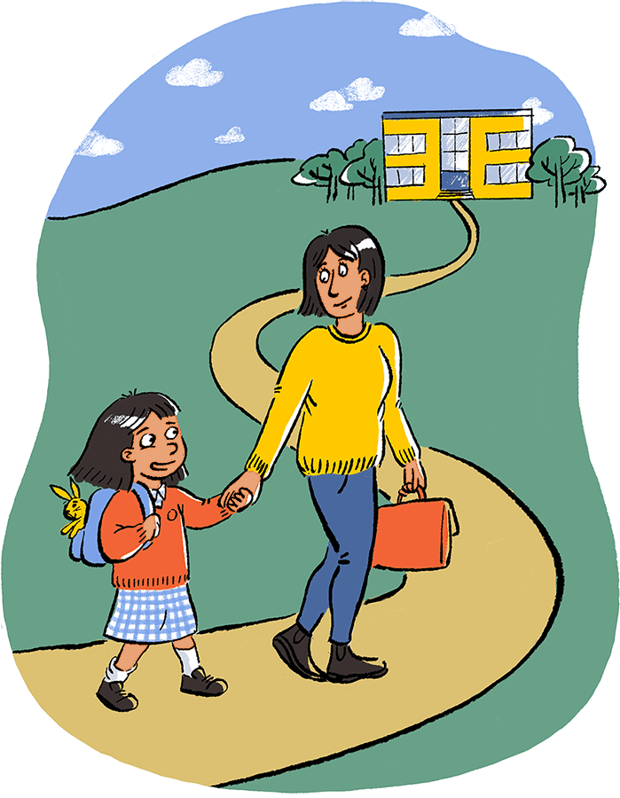
- Curious and confident about learning.
- Resilient and ready to take part.
- Able to take risks, ask questions and find solutions.
- Confidently active and be healthy.
- Independent with self-care skills.
- Comfortable to make friends and take turns.
- Cared for and feel safe and secure.
- Able to vocalise choices.

Access more great advice on: startingreception.co.uk

Schedule of Fees.
£6.50 an hour for 2 year olds.
£6.25 an hour for 3-4 year olds.
Late collection fees.
£12.50 for 10 minutes late.
£25.00 for 25 minutes late.
We do appreciate that sometimes the circumstances are out of parents control so enforcement of that fine is at the managers discretion. Any time that you are delayed and going to be late collecting your child, please call us and let the staff know so that they can settle and reassure your child while they are waiting.

07.1a Privacy notice
Hendred Preschool’s Privacy Notice
Hendred’s Preschool, Church Street, Snells Hall, OX12 8LA.

Introduction
Personal data is protected in accordance with data protection laws and used in line with your expectations. This privacy notice explains what personal data we collect, why we collect it, how we use it, the control you have over your personal data and the procedures we have in place to protect it.
When we refer to “we”, “us” or “our”, we mean Hendred’s Pre-school.
What personal data we collect at Hendred’s Preschool.
We collect personal data about you and your child to provide care and learning tailored to meet your child’s individual needs. Personal details that we obtain from you include your child’s: name, date of birth, address, and health, development and any special educational needs information. We will also ask for information about who has parental responsibility for your child and any court orders pertaining to your child.
Personal data that we collect about you includes: your name, home and work address, phone numbers, email address, emergency contact details, and family details.
We will only with your consent collect your national Insurance number or unique taxpayer reference (UTR) where necessary if you are self-employed and where you apply for up to 30 hours free childcare and early education. We also collect information regarding benefits and family credits. Please note that if this information is not provided, then we cannot claim funding for your child.
We also process financial information when you pay your childcare and early education fees by chip and pin or direct debit. We may collect other data from you when you voluntarily contact us.
Where applicable we will obtain details of your child’s social worker, child protection plans from social care, and health care plans from health professionals and other health agencies.
We may collect this information in a variety of ways. For example, data will be collected from you directly in the registration form; from identity documents; from correspondence with you; or from health and other professionals.

Why we collect personal data and the legal basis for handling your data
We use personal data about you and your child to provide childcare and early education services and to fulfil the contractual arrangement you have entered. This includes using your data in the following ways:
- To support your child’s wellbeing and development.
- To effectively manage any special education, health or medical needs of your child whilst at the setting.
- To carry out regular assessment of your child’s progress and to identify any areas of concern.
- To maintain relevant contact about your child’s wellbeing and development.
- To contact you in the case of an emergency.
- To process your claim for free childcare and early education, if applicable.
- To enable us to respond to any questions you ask.
- To keep you updated about information which forms part of your contract with us.
- To notify you of service changes or issues.
- To send you our e-newsletter, if you have subscribed to it.
With your consent, we would also like to:
- Collect your child’s ethnicity and religion data for monitoring purposes.
- Record your child’s activities for their individual learning journal (this will often include photographs and videos of children during play).
- Sign you up for our free parent e-newsletter which provides resources and useful information for parents.
- Transfer your child’s records to the receiving school when s/he transfers.
If we wish to use any images of your child for training, publicity or marketing purposes we will seek your written consent for each image we wish to use. You are able to withdraw your consent at any time, for images being taken of your child and/or for the transfer of records to the receiving school, by confirming so in writing to the setting. You can also unsubscribe from receiving our parent e-newsletter by notifying the setting.
We have a legal obligation to process safeguarding related data about your child should we have concerns about her/his welfare.

Who we share your data with
As a registered early years provider to deliver childcare and early education services it is necessary for us to share data about you and/or your child with the following categories of recipients:
- Ofsted, or the childminder agency (if registered with an agency) when there has been a complaint about the childcare and early education service or during an inspection.
- Banking services to process chip and pin and/or direct debit payments.
- The local authority if you claim up to 30 hours free childcare.
- The governments eligibility checker as above, if applicable.
- Our insurance underwriter, where applicable.
- An email newsletter service, where you have given consent to receive our e-newsletter.
We will also share your data:
- If we are legally required to do so, for example, by a law enforcement agency, court.
- To enforce or apply the terms and conditions of your contract with us.
- To protect your child and other children; for example, by sharing information with medical services, social services, or the police.
- If it is necessary to protect our rights, property, or safety or to protect the rights, property, or safety of others.
- With the school that your child will be attending, when they transfer, if applicable.
- If we transfer the management of the provision out or take over any other organisation or part of it, in which case we may disclose your personal data to the prospective seller or buyer so that they may continue using it in the same way.
Our nursery management and communication software provider may be able to access your personal data when carrying out maintenance task and software updates on our behalf. However, we have a written agreement in place which place this company under a duty of confidentiality.
We will never share your data with any organisation to use for their own purposes.
How do we protect your data?
We take the security of your personal data seriously. We have internal policies and strict controls in place to try to ensure that your data is not lost, accidentally destroyed, misused, or disclosed and to prevent unauthorised access.
Where we engage third parties to process personal data on our behalf, they are under a duty of confidentiality and are obliged to implement appropriate technical and organisational measures to ensure the security of data.
Where do we store your data?
All data you provide to us is stored on secure computers or servers located within the UK or European Economic Area. We may also store paper records in locked filing cabinets.
Our third-party data processors will also store your data on secure servers which may be situated inside or outside the European Economic Area. They may also store data in paper files.
How long do we retain your data?
We retain your data in line with our retention policy a summary is below:
- You and your child’s data, including registers are retained 3 years after your child no longer uses the setting, or until our next Ofsted, or childminder agency inspection after your child leaves our setting.
- Medication records and accident records are kept for longer according to legal requirements.
- Learning journeys are maintained by the setting and available at your request when your child leaves. Records are kept and archived in line with our data retention policy.
- In some cases (child protection or other support service referrals), we may need to keep your data longer, only if it is necessary to comply with legal requirements. We will only keep your data for as long as is necessary to fulfil the purposes it was collected for and in line with data protection laws.
Your rights with respect to your data
As a data subject, you have several rights. You can:
- request to access, amend or correct the personal data we hold about you and/or your child
- request that we delete or stop processing your and/or your child’s personal data, for example where the data is no longer necessary for the purposes of processing or where you wish to withdraw consent
- request that we transfer your and your child’s personal data to another person
If you wish to exercise any of these rights at any time please contact the manager at the setting by email, telephone or when you attend the setting.
How to ask questions about this notice
If you have any questions, comments, or concerns about any aspect of this notice or how we handle your data please contact the manager at the setting.
How to contact the Information Commissioner Office (ICO)
If the manager is not able to address your concern, please contact Amanda Cotter, Chair of Committee.
If you are concerned about the way your data is handled and remain dissatisfied after raising your concern, you have the right to complain to the Information Commissioner Office (ICO). The ICO can be contacted at Information Commissioner’s Office, Wycliffe House, Water Lane, Wilmslow, Cheshire, SK9 5AF or https://ico.org.uk/.
Changes to this notice
We keep this notice under regular review. Any changes to this notice will be shared with you so that you may be aware of how we always use your data.
Complaint procedure for parents.
There is a fair way of dealing with issues as they arise in an informal way, but parents/carers may wish to exercise their right to make a formal complaint. They are informed of the procedure to do this, and complaints are responded to in a timely way. The same procedures apply to agencies who may have a grievance or complaint.

Parents/carers

If a parent/carer is unhappy about any aspect of their child’s care or how they have been treated, this should be discussed with the child’s key person. The key person will listen to the parent/carer and acknowledge what they are unhappy about. The key person will offer an explanation and an apology if appropriate. The issue and how it was resolved is recorded in the child’s file and Complaint Investigation Record. The recording will also make clear whether the issue being raised relates to a concern about quality of the service or practice, or a complaint. For allegations relating to serious harm to a child caused by a member of staff or volunteer procedure 6.2 Allegations against staff, volunteers or agency staff will be followed.
- If the parent/carer is not happy with the key person’s response or wishes to complain about the key person or any other member of staff, they will be directed to the setting manager. Some parents/carers will want to make a written complaint; others will prefer to make it verbally; in which case the setting manager writes down the key issues of the complaint using the Complaint Investigation Record and keeps it in the child’s file.
- The setting manager will investigate the complaint and provide time to feedback to the parent/carer within 28 days. A confidential written report of the investigation is kept in the child’s file if the complaint relates directly to a child.
- If the parent/carer is still not satisfied, or if the complaint is about the setting manager, the setting manager is asked to forward their complaint verbally or in writing to their line manager.
- If the parent/carer is still not satisfied, then they are entitled to appeal the outcome verbally or in writing to the setting manager’s line manager who will pass the matter on to owners/directors/trustees for further investigation and will respond to the parent/carer within a further 14 days.
- If the complainant believes that the matter has not been resolved and there has been a breach of the EYFS requirements they are entitled to make a complaint to Ofsted or the childminder agency. The manager will assist in any complaint investigation as well as in producing documentation that records the steps that were taken in response to the original complaint.
- The setting manager ensures that parents/carers know they can complain to Ofsted by telephone or in writing at any time as follows:
Applications, Regulatory and Contact (ARC) Team, Ofsted, Piccadilly Gate, Store Street, Manchester M1 2WD or telephone: 0300 123 1231

Other services
- If an individual from another service wishes to make a formal complaint about a member of staff or any practice of the setting, it should be made in writing to the setting manager.
- The complaint is acknowledged in writing within 10 days of receiving it.
- The setting manager investigates the matter and meets with the individual to discuss the matter further within 28 days of the complaint being received.
- An agreement needs to be reached to resolve the matter.
- If agreement is not reached, the complainant may write to the setting manager’s line manager, who acknowledges the complaint within 5 days and reports back within 14 days.
- If the complainant is not satisfied with the outcome of the investigation, they are entitled to appeal and are referred to the owners/directors/trustees.
Ofsted complaints record
- Legislation requires settings to keep a record of complaints and disclose these to Ofsted, or the childminder agency at inspection, or if requested by Ofsted, or the childminder agency at any other time.
- The record of complaints is a summative record only.
- A record of complaints will be kept for at least 3 years.
- In all cases where a complaint is upheld a review will be undertaken by the owners/directors/trustees to look for ways to improve practice where it is required.
This procedure is displayed on Parent/Carer Notice Board.
Further guidance
Complaint Investigation Record (Alliance Publication)


The Hendred’s Preschool Complaint Form
Date of complaint:
Your name:
Your address:
Telephone:
Email:
Nature of complaint:
Please provide details of the complaint: eg location, date, nature of the activity, conduct of a member of staff, child or another adult including relevant names, and or any other important information on the nature of the complaint.

Signature: ……………………………………………………………………….
Date: …………………………………………………………………………….

